**Low Level Document**

**Amazon Sales and Revenue**

**Rashmi Dubey**

# Document Version Control:

|  |  |  |  |
| --- | --- | --- | --- |
| **Date** | **Version** | **Description** | **Author** |
| 13/02/2022 | 0.1 | First Version of Complete LLD | Rashmi Dubey |
|  |  |  |  |
|  |  |  |  |

**Content:**

Document Version Control 1

1. Introduction 2
   1. What is Low Level Design Document? 2
   2. Scope 2
   3. Project Introduction 2
2. Problem Statement 2
3. Dataset Information 2
4. Architecture 3
5. Architecture Description 3
   1. Raw Data Collection 3
   2. Data Preprocessing and Transformation 3
   3. Reporting 5
   4. Modelling 6
   5. Deployment 6

# Introduction:

## What is Low Level Design Document?

The goal of the Low-level design document (LLDD) is to give the internal logic design of the actual program code for the Sales dashboard. LLDD describes the class diagrams with the methods and relations between classes and programs specs. It describes the modules so that the programmer can directly code the program from the document.

* 1. **What is Scope?**

Low-level design (LLD) is a component-level design process that follows a step-by-step refinement process. The process can be used for designing data structures, required software architecture, source code and ultimately, performance algorithms. Overall, the data organization may be defined during requirement analysis and then refined during data design work.

## Project Introduction

Sales management has gained importance to meet increasing competition and the need for improved methods of distribution to reduce cost and to increase profits. The objective of this project is to perform data analysis and visualisation and built dashboards to provide insights that can help in making data driven decisions to increase sales and revenue of the company.

# Problem Statement :

The objective of this project is to analyse the Sales and Revenue trend. This project will help in identifying major markets in terms of Sales and Revenue.

# Dataset Information :

* Order ID : Unique Order ID number per Order
* Product : Name of ordered Product
* Quantity Ordered : Number of Items Ordered
* Price Each : Price of one item (in $)
* Order Date : Date when order was placed
* City : City from where order was placed
* State : State from where order was placed
* Category : Category of the ordered Produce

# Architecture :

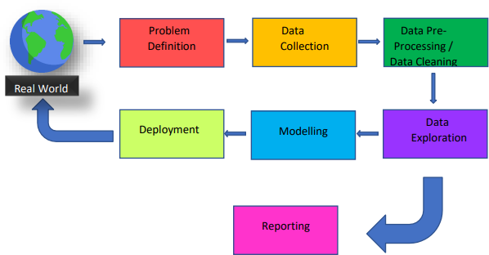

# Architecture Description:

* 1. **Raw Data Collection:**

The dataset is an open source and taken from Kaggle website.

* 1. **Data Pre-processing and Transformation:**

Before building any model, it is crucial to perform data pre-processing and transformation to feed the correct data to the model to analyse and visualise the data. The process includes:

* + 1. **Handling Null/Missing Values :**

There were only few rows which were completely null, so those values were removed from the dataset.

**Raw Data**

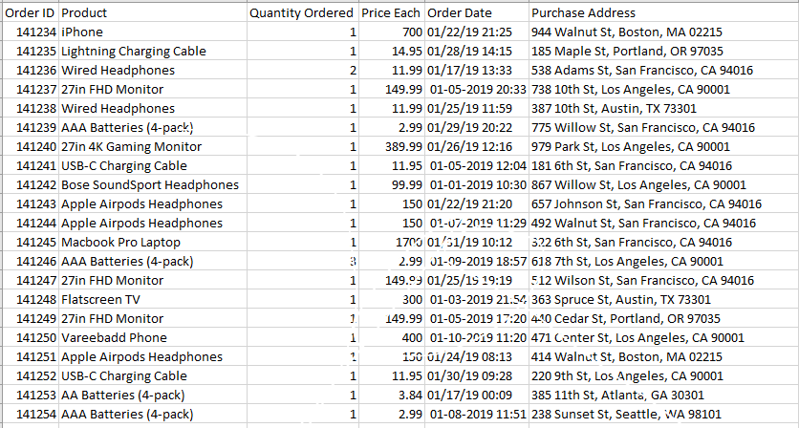

* + 1. **Data Transformation:**

From raw dataset, we have to derive some columns which were necessary for data analysis and dashboard building.

* + - * City and State Columns were derived from Purchase Address Column from raw dataset and after extracting columns, Purchase Address column was dropped.
      * Based on the Product name, Category Column was created which specified the Category of product like Laptop, Phone, TV etc.

**Transformed Data**

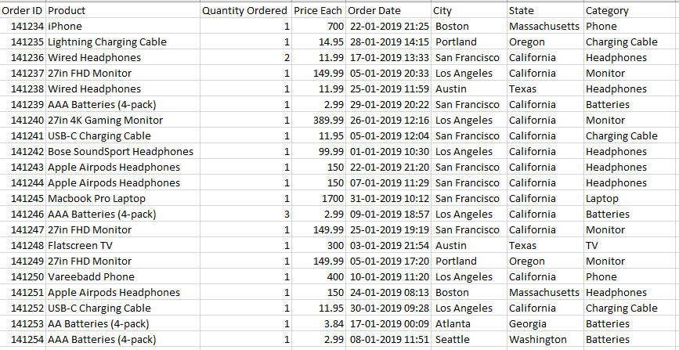

* 1. **Reporting :**

Reporting is a most important and underrated skill of a data analytics field. Because being a Data Analyst you should be good in easy and self-explanatory report because your model will be used by many stakeholders who are not from technical background.

* + 1. High Level Design Document (HLD)
    2. Low Level Design Document (LLD)
    3. Architecture
    4. Wireframe
    5. Detailed Project Report
    6. Power Point Presentation
  1. **Modelling :**

Data Modelling is the process of analysing the data objects and their relationship to the other objects. It is used to analyse the data requirements that are required for the business processes. The data models are created for the data to be stored in a database. The Data Model's main focus is on what data is needed and how we have to organize data rather than what operations we have to perform.

* 1. **Deployment :**

Power BI is used to build reports and dashboard. Power BI file is then uploaded to Power BI Web service from where client can access using Power BI account.

